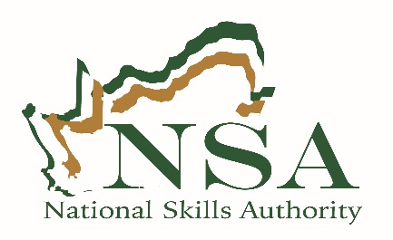
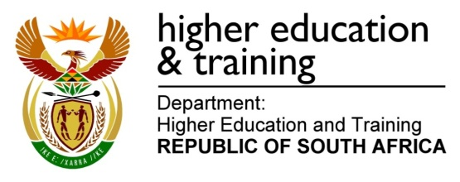

Enquiries: Dr Thabo Mashongoane Tel: (012) 312 5420 E-Mail: Mashongoane.T@dhet.gov.za
NSA & NORTHERN CAPE
SKILLS DEVELOPMENT ROUND TABLE DISCUSSION
10 OCTOBER 2017

On Tuesday, 10 October 2017 the National Skills Authority (NSA) held a skills development
Roundtable discussion in the Northern Cape bringing together 200 representatives from
government, business, organized labour, SETAs, NGO’s, CBO’s, institutions of higher learning
and private training providers, etc.

The purpose of the round table discussion was to bring together all skills development role
players within the province to discuss the challenges and blockages experienced in the
implementation of skills development interventions and find possible solutions on how to
unblock them.

The round table sought to encourage thoughts/discussion on:
- Fostering a common understanding of the roles and responsibilities of various stakeholders in the skills development landscape.
- Skills development challenges confronting the province.
- Building partnerships between all spheres of government and the private sector to enhance maximum participation of all sectors.
- Commission research to determine the magnitude of SETA challenges and the value of their contribution within the province.
- Possible interventions for the identified challenges.
- Developing an action plan with clear timeframes on resolutions captured.

Kindly visit the NSA website for the NSA Chairperson’s speech, concept document and pledges.

For Enquiries:
Dr Thabo Mashongoane
Tel: (012) 312 5420
Email: Mashongoane.T@dhet.gov.za
www.nationalskillsauthority.org.za

